**Assignment2 Sample Application**

**This is a sample application and it shows how to create RadioButtons, TextBoxes and PushButtons and how to use RadioButtons for selecting a particular option which enables textboxes associated with the selected radioButtons. The submit button when pressed retrieve the text from textboxes and displays the retrieved text using JOptionPane.**

1. File 🡪New Project🡪Categories🡪Java🡪Next

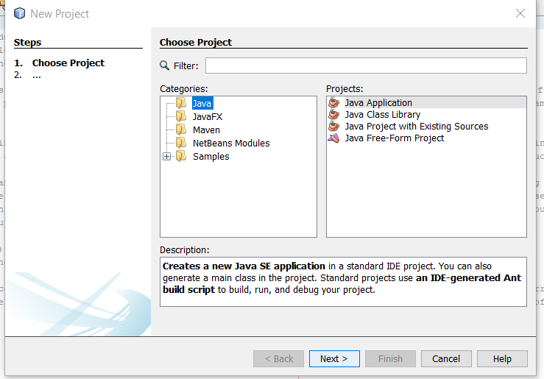

Figure 1

Project Name: BankGuiA3TTU

Project Location: Browse to the Location

Uncheck (the check box: Create MainClass

& then press the finish Button

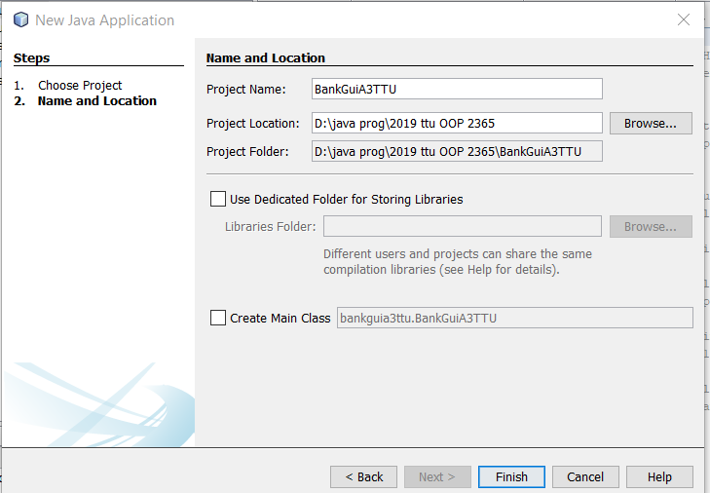

Figure 2

Now this would launch you into the following window

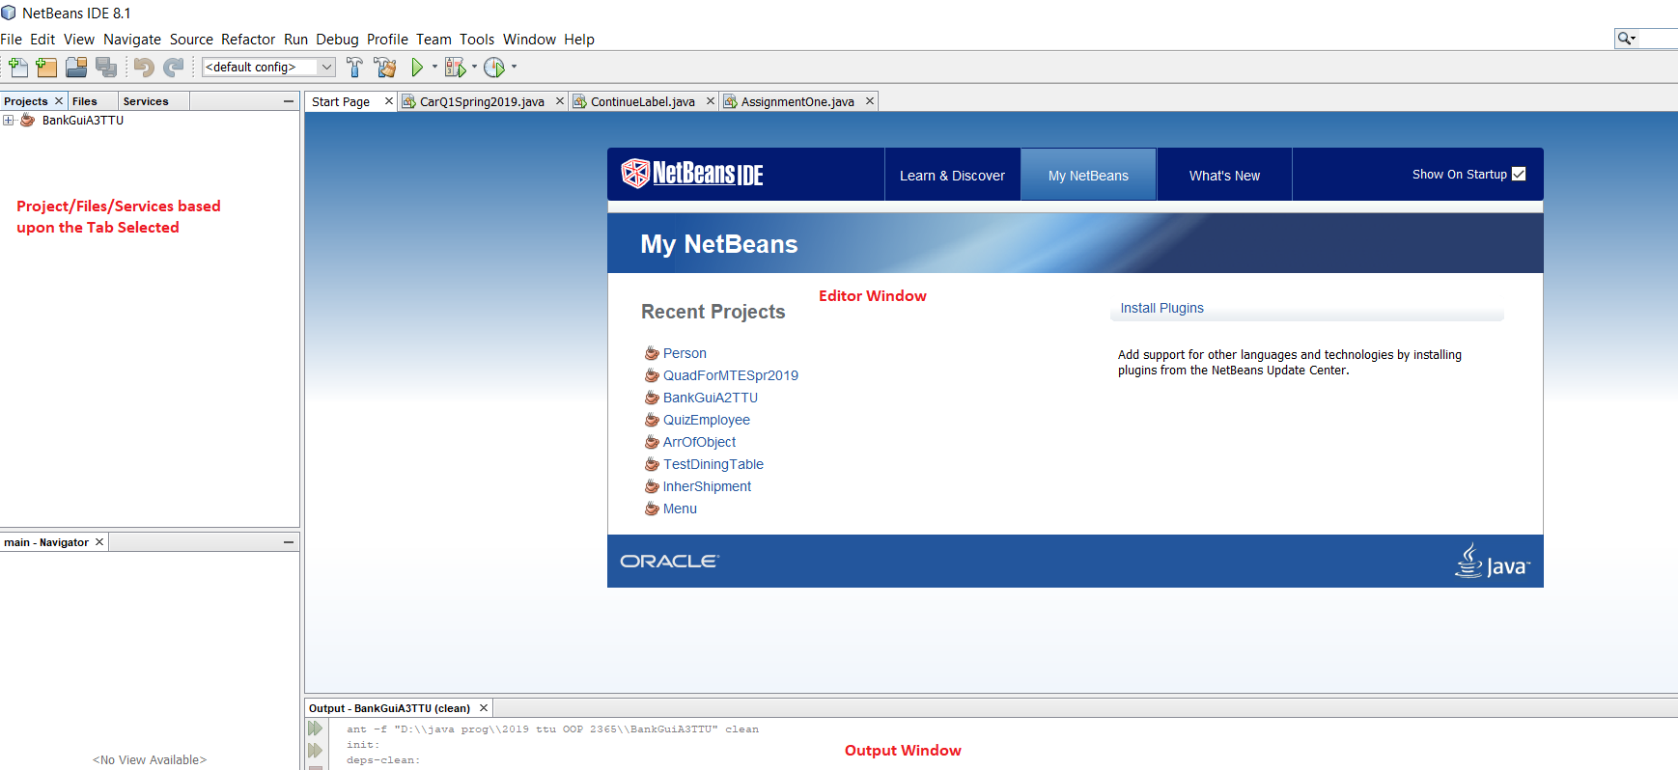

Figure 3

In the above figure you are seeing 3 windows: 1. Project/Files/Services window on your left. You may call it **Project Window** because right now the project tab is selected.2. **Editor Window**, in which you would write your code 3. **Output Window** where you can see the output of System.out.println statement. Here you create a Frame (container) for your GUI application. The steps for creating the Frame Window are as follows:

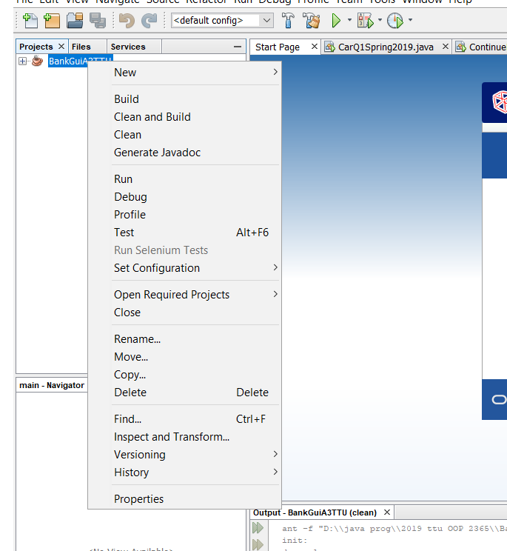

Figure 4

1. Select your project from the project Application and then right click, a window would pop-up. Click on the New option:

Another window pops up as shown below:

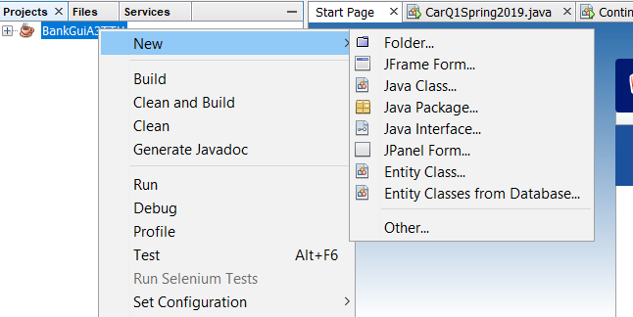

Figure 5

Select the JFrame Form….it would ask you the name for JFrame class. For tracking purposes, give it a name like:

Your ProjectName _Frame as shown below:

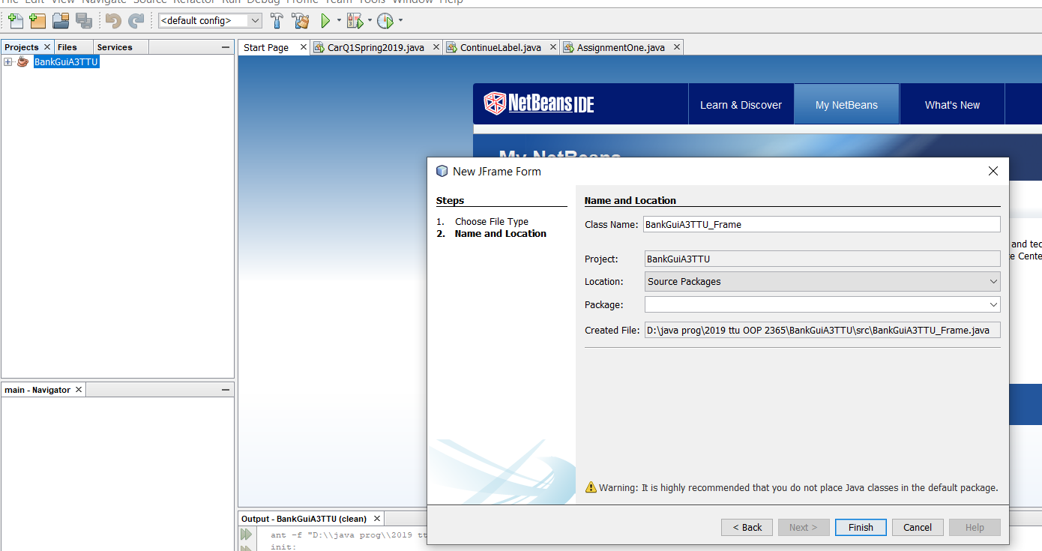

Figure 6

Now click the Finish button.

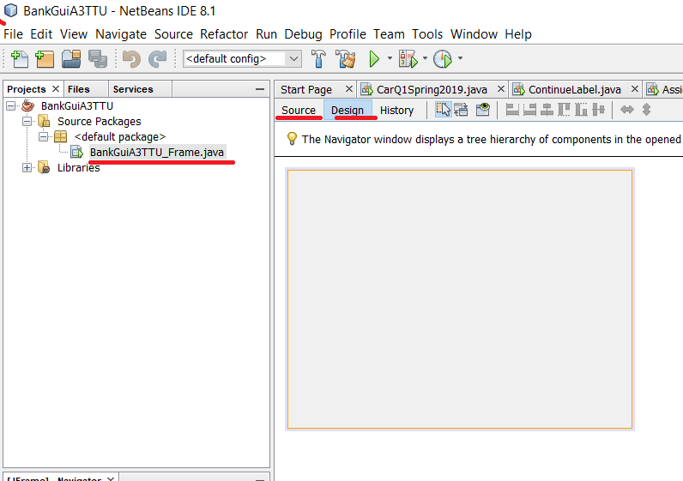

Figure 7

Now you would see the above chnges. Please notice the red underlined stuff (like the name of your **frame class**, **Source tab** and the **Design tab**. If you can’t see this, then it means you forgot to uncheck “Create Main class” in Figure 2. Do again. However, if you have reached this step then select the grey windowand and enlarge it in the Editor window. Note “Design” tab is used to see your GUI components which are part of your program. They are also known as controls in other language. I may use these terms interchangeably. “Source” tab displays your code. You can switch between Design View and Source View several times during your code development. “Design” view also helps you to edit text related to your controls (i.e caption or title), assign variables to your controls, create methods related to your controls also known as call back function.

After enlarging the Editor window, you can see the following screen along with the pallete which would show you the GUI controls in java and you can drag these controls on your Editor.

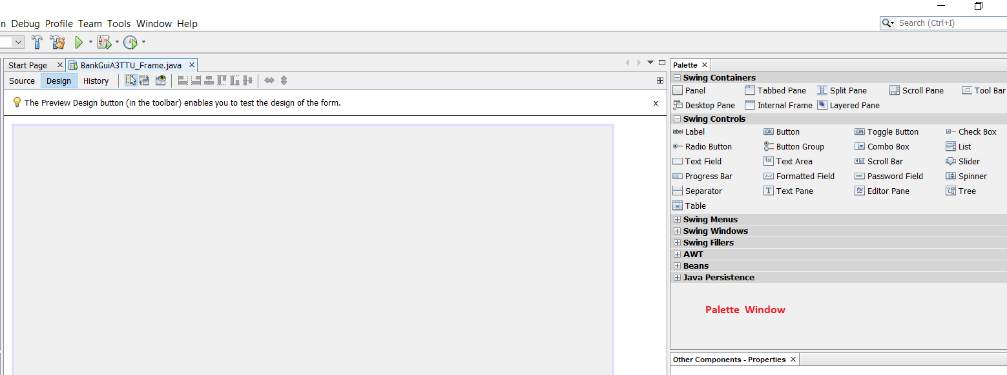

Figure 8

Now you have to drag 5 Radio Buttons from the Palette window to your application

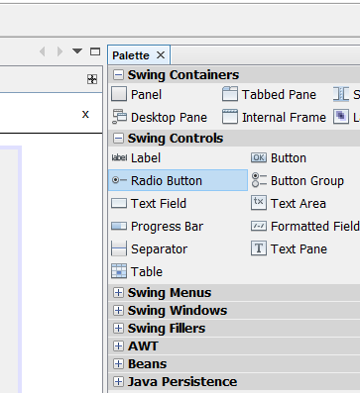

Figure 9

After dragging the 5 radio buttons, your design view would look something similar to the figure 10, shown below:

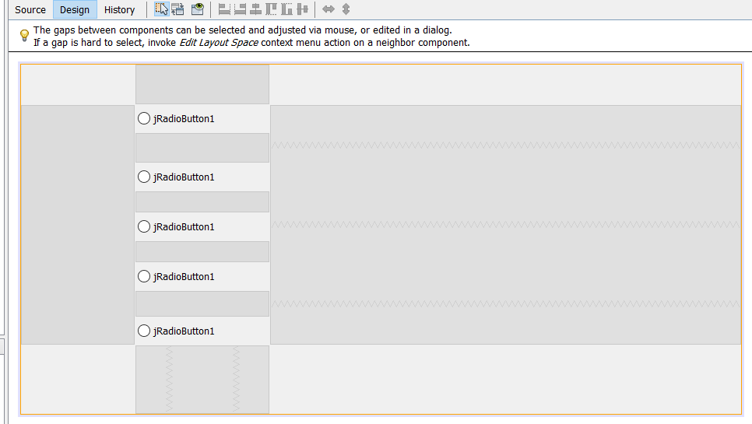

Figure 10

Figure 10 shows you the 5 radio buttons along with their captions. Now try to change the captions of each radio button by selecting the radio button and then pressing the right mouse key

When you select the radio button and then press the right mouse key, a window would pop up. As shown in Figure 11.

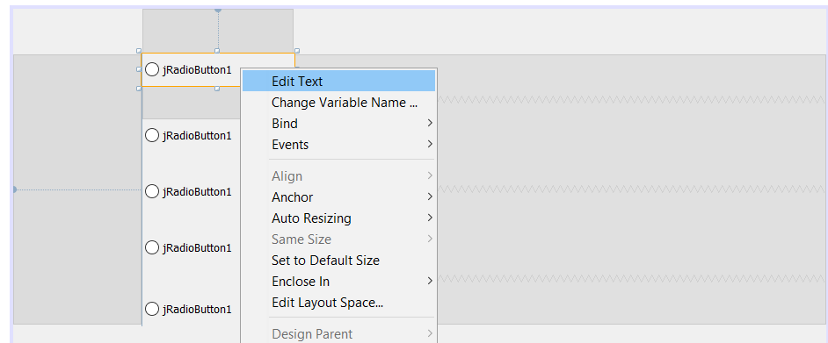

Figure 11

Select the first option i.e. “Edit Text”. I have changed the captions to ”Option1”, “Option2” and so on as shown in Figure 12. You have to change it corresponding to the options provided in your Assignment2’s question sub-parts.

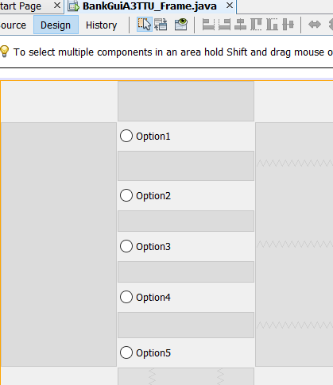

Figure 12

Now we would change the names of variables associated with radio buttons. You have to use these variable names for further processing. You would do it like the previous step but you would choose a different option from the popup menu. For changing variable name you would use “Change Variable name…” instead of “Edit Text” option. Right click on the radio button control named option1 and click on “Change Variable Name” as shown below:

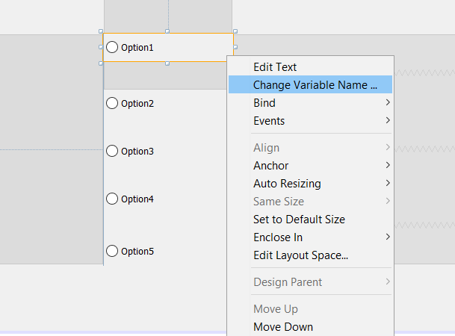

A following window would pop-up when you click on Change Variable Name… as shown below:

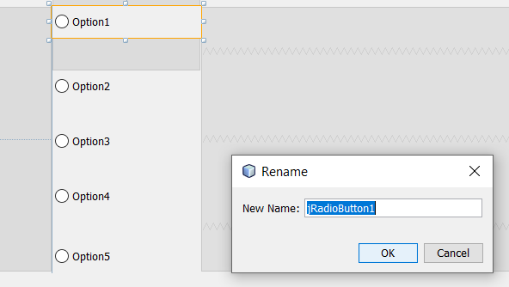

Type the new name starting with ‘m’. We would declare all our control variables names such that they start with character ‘m’. This would help us in identifying control variables. For convenience, we can name the radio buttons’ variables as : mRb1, mRb2….mRb5.Once you create these variable names, you can locate them at the bottom of your source file. This would help you to remember their names if by chance you forget their names. Following is the list of component variables you have created until now:

private javax.swing.JRadioButton **mRb1**;

private javax.swing.JRadioButton **mRb2**;

private javax.swing.JRadioButton **mRb3**;

private javax.swing.JRadioButton **mRb4**;

private javax.swing.JRadioButton **mRb5**;

Now we would create Action Event handlers for radio buttons called actionPerformed methods. We would again follow the same procedure as we did previously like right clicking the radio button component but this time we would select Events🡪Action🡪actionPerformed

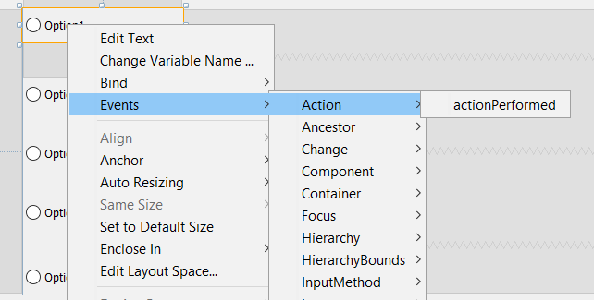

Note when we would do the above step for radio button named option1, we would get following skeleton code added in the java source file. The following skeleton code represents the 5 five call back functions or event handlers. “event-handlers” means a method or function which would handle an event. In this case, clicking of radio button is an event. Thus these handlers would be invoked when the button click event occurs.

private void **mRb1**ActionPerformed(java.awt.event.ActionEvent evt) {

// TODO add your handling code here:

}

private void **mRb2**ActionPerformed(java.awt.event.ActionEvent evt) {

// TODO add your handling code here:

}

private void **mRb3**ActionPerformed(java.awt.event.ActionEvent evt) {

// TODO add your handling code here:

}

private void **mRb4**ActionPerformed(java.awt.event.ActionEvent evt) {

// TODO add your handling code here:

}

private void **mRb5**ActionPerformed(java.awt.event.ActionEvent evt) {

// TODO add your handling code here:

}

Now create 10 text boxes by dragging Text Field controls from Swing controls palette as shown below:

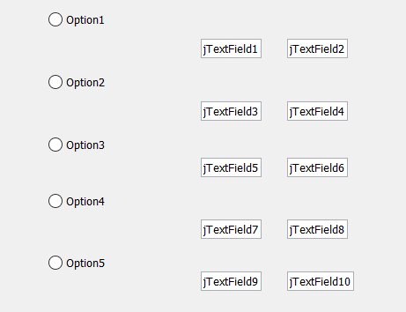

As you can see TextFilelds contain some text. Remove the text by right click on text field (whose text you want to delete and then press properties as shown blow:

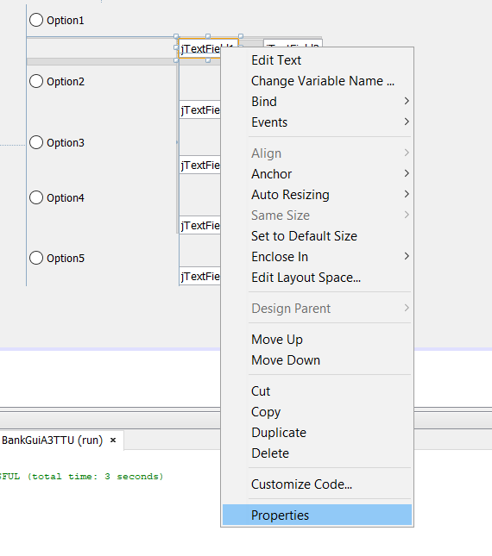

This would popup properties window. Goto “text” and select text and press delete. You may need to readjust the text field.

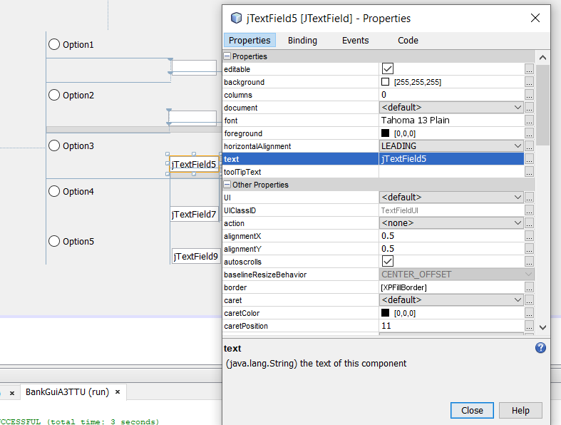

Note you can delete text also by selecting the text and then pressing the delete button while you are in the design view.Once you delete all text from all text fields, you would have following opening window of application: Note you can enable all radio buttons at this point because you have not activated the group property for radio buttons.

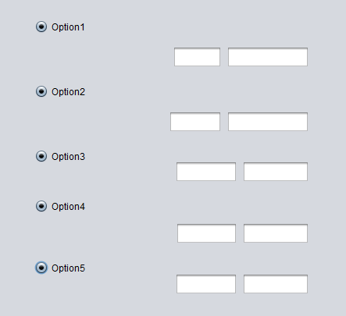

As you can see the problem with above figure is that all radio buttons are activated at the same time. We don’t want this. So now we would activate the group property for radio buttons so that only one radio button is activated at a time. Also at startup, we want to disable all text fields. We want to enable the textfields if the radio button associated with it is clicked. So first we would do two things:

1. Set the group property for radio buttons so that only one radio button is activated at a time
2. At start up all text fields should be grayed (disable)

The code for the above (i) tasks is given below:

ButtonGroup group = new ButtonGroup();

group.add(mRb1);

group.add(mRb2);

group.add(mRb3);

group.add(mRb4);

group.add(mRb5);

Write the above code in the constructor of your frame class i.e. BankGuiA3TTU_Frame(){ ..} i.e.

**public BankGuiA3TTU_Frame()** {

initComponents();

ButtonGroup group = new ButtonGroup();

group.add(mRb1);

group.add(mRb2);

group.add(mRb3);

group.add(mRb4);

group.add(mRb5);

}

After this, you would be able to click only one radio button at a time:

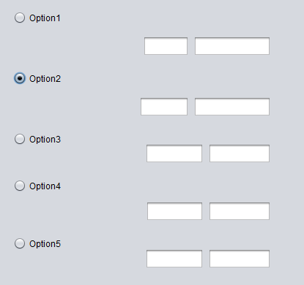

To disable the textfields, you have to assign them variable names. Textfield variables associated with radio button (i.e. radio button named :Option1) can be named as:

mTF11, mTF12 &(Note textfield variable names are prefixed by ‘m’)

Textfields associated with radio button (i.e. radio button named :Option2) can be named as:

mTF21, mTF22 and so on.

For assigning names to the textfields, we would right click on the textfield and then select the option “Change Variable Name…..” from the popup window as shown below:

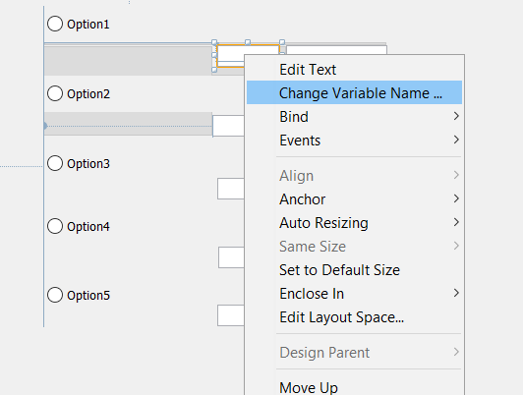

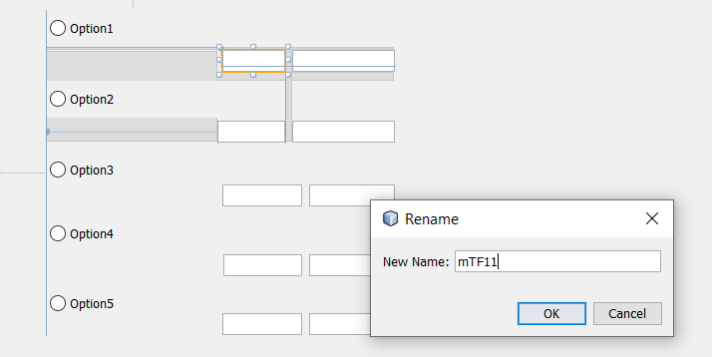

The names of all control variables’ names are shown below at the bottom of java source file:

// Variables declaration - do not modify

private javax.swing.JRadioButton mRb1;

private javax.swing.JRadioButton mRb2;

private javax.swing.JRadioButton mRb3;

private javax.swing.JRadioButton mRb4;

private javax.swing.JRadioButton mRb5;

private javax.swing.JTextField mTF11;

private javax.swing.JTextField mTF12;

private javax.swing.JTextField mTF21;

private javax.swing.JTextField mTF22;

private javax.swing.JTextField mTF31;

private javax.swing.JTextField mTF32;

private javax.swing.JTextField mTF41;

private javax.swing.JTextField mTF42;

private javax.swing.JTextField mTF51;

private javax.swing.JTextField mTF52;

Now we are in a position to disable the textfields at the start of application by adding following statements in the constructor of *_Frame class i.e. BankGuiA3TTU_Frame

import javax.swing.*;

public class **BankGuiA3TTU_Frame** extends javax.swing.JFrame {

/**

* Creates new form BankGuiA3TTU_Frame

*/

public BankGuiA3TTU_Frame() {

initComponents();

ButtonGroup group = new ButtonGroup();

group.add(mRb1);

group.add(mRb2);

group.add(mRb3);

group.add(mRb4);

group.add(mRb5);

//disable the text fields

**mTF11.setEnabled(false);**

**mTF12.setEnabled(false);**

**mTF21.setEnabled(false);**

**mTF22.setEnabled(false);**

**mTF31.setEnabled(false);**

**mTF32.setEnabled(false);**

**mTF41.setEnabled(false);**

**mTF42.setEnabled(false);**

**mTF51.setEnabled(false);**

**mTF52.setEnabled(false);**

}

As a result of the above instructions, the text fields are disabled now. Now, we would enable the text fields corresponding to the radio button being clicked. For this purpose, we would use the statements:

**mTF11.setEnabled(true);**

**mTF12.setEnabled(true);**

**mTF21.setEnabled(false);**

**mTF22.setEnabled(false);**

**mTF31.setEnabled(false);**

**mTF32.setEnabled(false);**

**mTF41.setEnabled(false);**

**mTF42.setEnabled(false);**

**mTF51.setEnabled(false);**

**mTF52.setEnabled(false);**

in **mRb1**ActionPerformed(java.awt.event.ActionEvent evt)

and statements like:

**mTF11.setEnabled(false);**

**mTF12.setEnabled(false);**

**mTF21.setEnabled(true);**

**mTF22.setEnabled(true);**

**mTF31.setEnabled(false);**

**mTF32.setEnabled(false);**

**mTF41.setEnabled(false);**

**mTF42.setEnabled(false);**

**mTF51.setEnabled(false);**

**mTF52.setEnabled(false);**

**in mRb2**ActionPerformed(java.awt.event.ActionEvent evt)

and so on.

The code of two actionPerformed methods is shown below:

**private void mRb1ActionPerformed(java.awt.event.ActionEvent evt) {**

// TODO add your handling code here:

mTF11.setEnabled(true);

mTF12.setEnabled(true);

mTF21.setEnabled(false);

mTF22.setEnabled(false);

mTF31.setEnabled(false);

mTF32.setEnabled(false);

mTF41.setEnabled(false);

mTF42.setEnabled(false);

mTF51.setEnabled(false);

mTF52.setEnabled(false);

}

**private void mRb2ActionPerformed(java.awt.event.ActionEvent evt) {**

// TODO add your handling code here:

mTF11.setEnabled(false);

mTF12.setEnabled(false);

mTF21.setEnabled(true);

mTF22.setEnabled(true);

mTF31.setEnabled(false);

mTF32.setEnabled(false);

mTF41.setEnabled(false);

mTF42.setEnabled(false);

mTF51.setEnabled(false);

mTF52.setEnabled(false);

}

As a result of the above code, we can achieve the following:

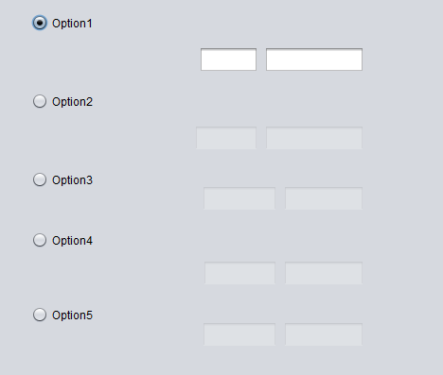

And so on….:

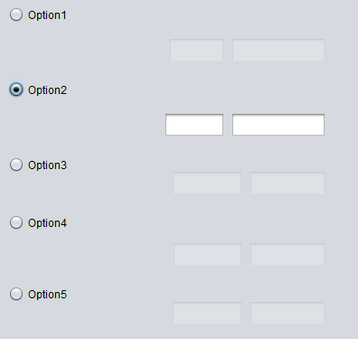

Now we would create a button and call it “Submit” and then provide the actionPerformed handler for the button in the same manner as we provided the actionPerformed handler for the radio buttons. After that, we would write the code for the actionPerformed handler of the button. The button handler would perform some operations based upon the value typed in the text fields like concatenating the text of two text fields, and adding the numerical values. For adding of numerical values, we would consider that the data is of type Integer. For creating the button, we would drag a button from the palette control as shown below:

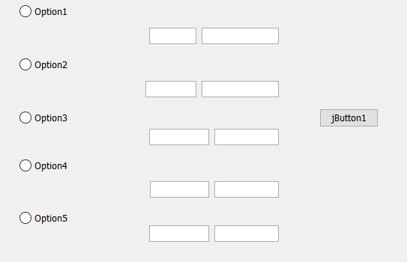

Now we would name the button as “Submit” in the same way as we named the radio buttons i.e. right click on the button and then select “Edit Text” option as shown below:

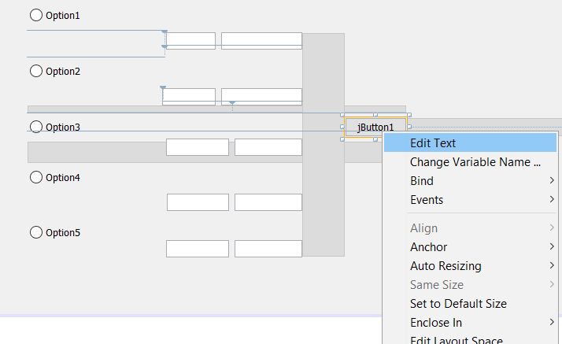

After changing the button’s name to “Submit”, we would again right click on the button and provide the event handler by clicking on Events🡪Action🡪actionPerformed as shown below:

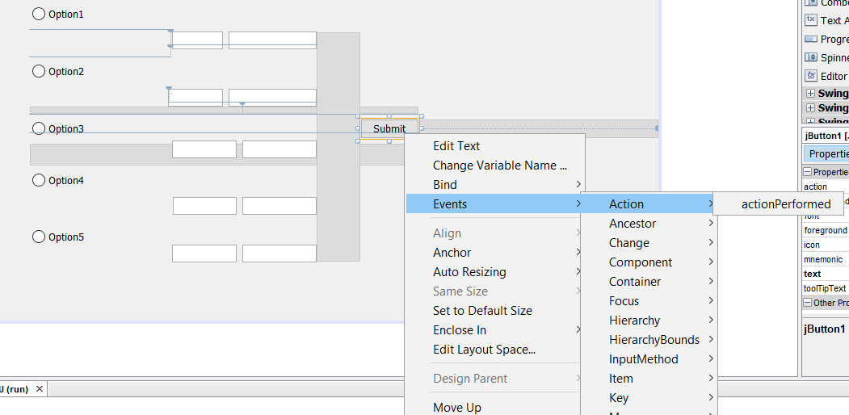

After the above step, we would see the following skeleton code of actionPerformed method created in java source file as shown below:

**private void submitActionPerformed(java.awt.event.ActionEvent evt) {**

**// TODO add your handling code here:**

**}**

Now we would find out which radio button is selected i.e. if radio button1 is selected, we would concatenate the strings, if radio button2 is selected, we add the numerical values (we are supposing that the values should be integer and not testing for the values being integer) and so on. In your program you would write the code according to your task asked in the question.

For performing the operation according to the radio button clicked, we have to use some boolean variables to let us know which radio button is clicked. So we would create 3 boolean instance variables like this :

boolean bmRb1= false;

boolean bmRb2=false;

boolean bmRb3=false;

and so on

and then modify the radio button’s action performed method like this:

**private void mRb1ActionPerformed(java.awt.event.ActionEvent evt)** {

// TODO add your handling code here:

**bmRb1 = true;//i.e. radio button Option1 clicked**

**bmRb2 = false;**

**bmRb3 = false;**

mTf11.setEnabled(true);

mTf12.setEnabled(true);

mTf21.setEnabled(false);

mTf22.setEnabled(false);

mTf31.setEnabled(false);

mTf32.setEnabled(false);

}

**private void mRb2ActionPerformed(java.awt.event.ActionEvent evt)** {

// TODO add your handling code here:

**bmRb1 = false;**

**bmRb2 = true; //i.e. radio button Option2 clicked**

**bmRb3 = false;**

mTf11.setEnabled(false);

mTf12.setEnabled(false);

mTf21.setEnabled(true);

mTf22.setEnabled(true);

mTf31.setEnabled(false);

mTf32.setEnabled(false);

}

Thus. to know which radio button is clicked, we would use the condition :

if(bmRb1){

}else if(bmRb2){

} else if(bmRb3) {

}

supposing you have 3 radio buttons.

Due to shortage of time, I am just focusing on String concatenation. The “submit” button handler for string concatenation for 3 radio buttons is given below:

private void btnSubmitActionPerformed(java.awt.event.ActionEvent evt) {

// TODO add your handling code here:

if(bmRb1){

String str1 = mTf11.getText();

String str2 = mTf12.getText();

JOptionPane.showMessageDialog(null, str1 + str2);

}

else if(bmRb2){

String str1 = mTf21.getText();

String str2 = mTf22.getText();

JOptionPane.showMessageDialog(null, str1 + str2);

}

else if(bmRb3){

String str1 = mTf31.getText();

String str2 = mTf32.getText();

JOptionPane.showMessageDialog(null, str1 + str2);

} and so on….

}

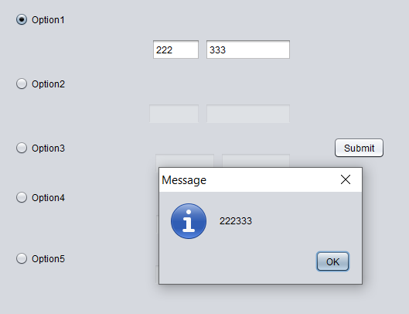

**THE CODE OF APPLICATION**

**import javax.swing.*;**

**public class BankGuiA3TTU_Frame extends javax.swing.JFrame {**

**boolean bmRb1= false; boolean bmRb2=false; boolean bmRb3=false;boolean bmRb4 =false;**

**boolean bmRb5 = false;**

**/\*\***

**\* Creates new form BankGuiA3TTU_Frame**

**\*/**

**public BankGuiA3TTU_Frame() {**

**initComponents();**

**ButtonGroup group = new ButtonGroup();**

**group.add(mRb1);**

**group.add(mRb2);**

**group.add(mRb3);**

**group.add(mRb4);**

**group.add(mRb5);**

**//disable the text fields**

**mTF11.setEnabled(false);**

**mTF12.setEnabled(false);**

**mTF21.setEnabled(false);**

**mTF22.setEnabled(false);**

**mTF31.setEnabled(false);**

**mTF32.setEnabled(false);**

**mTF41.setEnabled(false);**

**mTF42.setEnabled(false);**

**mTF51.setEnabled(false);**

**mTF52.setEnabled(false);**

**}**

**/\*\***

**\* This method is called from within the constructor to initialize the form.**

**\* WARNING: Do NOT modify this code. The content of this method is always**

**\* regenerated by the Form Editor.**

**\*/**

**@SuppressWarnings("unchecked")**

**// <editor-fold defaultstate="collapsed" desc="Generated Code">**

**private void initComponents() {**

**mRb1 = new javax.swing.JRadioButton();**

**mRb3 = new javax.swing.JRadioButton();**

**mRb4 = new javax.swing.JRadioButton();**

**mRb5 = new javax.swing.JRadioButton();**

**mRb2 = new javax.swing.JRadioButton();**

**mTF11 = new javax.swing.JTextField();**

**mTF12 = new javax.swing.JTextField();**

**mTF21 = new javax.swing.JTextField();**

**mTF22 = new javax.swing.JTextField();**

**mTF31 = new javax.swing.JTextField();**

**mTF32 = new javax.swing.JTextField();**

**mTF41 = new javax.swing.JTextField();**

**mTF42 = new javax.swing.JTextField();**

**mTF51 = new javax.swing.JTextField();**

**mTF52 = new javax.swing.JTextField();**

**submit = new javax.swing.JButton();**

**setDefaultCloseOperation(javax.swing.WindowConstants.EXIT_ON_CLOSE);**

**mRb1.setText("Option1");**

**mRb1.addActionListener(new java.awt.event.ActionListener() {**

**public void actionPerformed(java.awt.event.ActionEvent evt) {**

**mRb1ActionPerformed(evt);**

**}**

**});**

**mRb3.setText("Option3");**

**mRb3.addActionListener(new java.awt.event.ActionListener() {**

**public void actionPerformed(java.awt.event.ActionEvent evt) {**

**mRb3ActionPerformed(evt);**

**}**

**});**

**mRb4.setText("Option4");**

**mRb4.addActionListener(new java.awt.event.ActionListener() {**

**public void actionPerformed(java.awt.event.ActionEvent evt) {**

**mRb4ActionPerformed(evt);**

**}**

**});**

**mRb5.setText("Option5");**

**mRb5.addActionListener(new java.awt.event.ActionListener() {**

**public void actionPerformed(java.awt.event.ActionEvent evt) {**

**mRb5ActionPerformed(evt);**

**}**

**});**

**mRb2.setText("Option2");**

**mRb2.addActionListener(new java.awt.event.ActionListener() {**

**public void actionPerformed(java.awt.event.ActionEvent evt) {**

**mRb2ActionPerformed(evt);**

**}**

**});**

**submit.setText("Submit");**

**submit.addActionListener(new java.awt.event.ActionListener() {**

**public void actionPerformed(java.awt.event.ActionEvent evt) {**

**submitActionPerformed(evt);**

**}**

**});**

**javax.swing.GroupLayout layout = new javax.swing.GroupLayout(getContentPane());**

**getContentPane().setLayout(layout);**

**layout.setHorizontalGroup(**

**layout.createParallelGroup(javax.swing.GroupLayout.Alignment.LEADING)**

**.addGroup(layout.createSequentialGroup()**

**.addGap(146, 146, 146)**

**.addGroup(layout.createParallelGroup(javax.swing.GroupLayout.Alignment.LEADING)**

**.addGroup(layout.createSequentialGroup()**

**.addGap(172, 172, 172)**

**.addGroup(layout.createParallelGroup(javax.swing.GroupLayout.Alignment.TRAILING)**

**.addComponent(mTF11, javax.swing.GroupLayout.PREFERRED_SIZE, 63, javax.swing.GroupLayout.PREFERRED_SIZE)**

**.addComponent(mTF21, javax.swing.GroupLayout.PREFERRED_SIZE, 68, javax.swing.GroupLayout.PREFERRED_SIZE))**

**.addPreferredGap(javax.swing.LayoutStyle.ComponentPlacement.RELATED)**

**.addGroup(layout.createParallelGroup(javax.swing.GroupLayout.Alignment.LEADING)**

**.addComponent(mTF22)**

**.addComponent(mTF12)))**

**.addGroup(layout.createSequentialGroup()**

**.addGroup(layout.createParallelGroup(javax.swing.GroupLayout.Alignment.LEADING, false)**

**.addGroup(layout.createSequentialGroup()**

**.addComponent(mRb3, javax.swing.GroupLayout.PREFERRED_SIZE, 174, javax.swing.GroupLayout.PREFERRED_SIZE)**

**.addPreferredGap(javax.swing.LayoutStyle.ComponentPlacement.RELATED)**

**.addGroup(layout.createParallelGroup(javax.swing.GroupLayout.Alignment.TRAILING)**

**.addComponent(mTF31, javax.swing.GroupLayout.PREFERRED_SIZE, 80, javax.swing.GroupLayout.PREFERRED_SIZE)**

**.addComponent(mTF41, javax.swing.GroupLayout.PREFERRED_SIZE, 79, javax.swing.GroupLayout.PREFERRED_SIZE)))**

**.addComponent(mRb2, javax.swing.GroupLayout.PREFERRED_SIZE, 174, javax.swing.GroupLayout.PREFERRED_SIZE)**

**.addGroup(layout.createSequentialGroup()**

**.addComponent(mRb5, javax.swing.GroupLayout.PREFERRED_SIZE, 174, javax.swing.GroupLayout.PREFERRED_SIZE)**

**.addPreferredGap(javax.swing.LayoutStyle.ComponentPlacement.RELATED)**

**.addComponent(mTF51))**

**.addComponent(mRb4, javax.swing.GroupLayout.PREFERRED_SIZE, 174, javax.swing.GroupLayout.PREFERRED_SIZE)**

**.addComponent(mRb1, javax.swing.GroupLayout.PREFERRED_SIZE, 174, javax.swing.GroupLayout.PREFERRED_SIZE))**

**.addPreferredGap(javax.swing.LayoutStyle.ComponentPlacement.RELATED)**

**.addGroup(layout.createParallelGroup(javax.swing.GroupLayout.Alignment.LEADING)**

**.addComponent(mTF52, javax.swing.GroupLayout.DEFAULT_SIZE, 92, Short.MAX_VALUE)**

**.addComponent(mTF32)**

**.addComponent(mTF42))))**

**.addGap(54, 54, 54)**

**.addComponent(submit)**

**.addGap(296, 296, 296))**

**);**

**layout.setVerticalGroup(**

**layout.createParallelGroup(javax.swing.GroupLayout.Alignment.LEADING)**

**.addGroup(layout.createSequentialGroup()**

**.addGap(51, 51, 51)**

**.addComponent(mRb1, javax.swing.GroupLayout.PREFERRED_SIZE, 37, javax.swing.GroupLayout.PREFERRED_SIZE)**

**.addPreferredGap(javax.swing.LayoutStyle.ComponentPlacement.RELATED)**

**.addGroup(layout.createParallelGroup(javax.swing.GroupLayout.Alignment.BASELINE)**

**.addComponent(mTF11, javax.swing.GroupLayout.PREFERRED_SIZE, javax.swing.GroupLayout.DEFAULT_SIZE, javax.swing.GroupLayout.PREFERRED_SIZE)**

**.addComponent(mTF12, javax.swing.GroupLayout.PREFERRED_SIZE, javax.swing.GroupLayout.DEFAULT_SIZE, javax.swing.GroupLayout.PREFERRED_SIZE))**

**.addPreferredGap(javax.swing.LayoutStyle.ComponentPlacement.UNRELATED)**

**.addComponent(mRb2, javax.swing.GroupLayout.PREFERRED_SIZE, 37, javax.swing.GroupLayout.PREFERRED_SIZE)**

**.addPreferredGap(javax.swing.LayoutStyle.ComponentPlacement.RELATED)**

**.addGroup(layout.createParallelGroup(javax.swing.GroupLayout.Alignment.BASELINE)**

**.addComponent(mTF21, javax.swing.GroupLayout.PREFERRED_SIZE, javax.swing.GroupLayout.DEFAULT_SIZE, javax.swing.GroupLayout.PREFERRED_SIZE)**

**.addComponent(mTF22, javax.swing.GroupLayout.PREFERRED_SIZE, javax.swing.GroupLayout.DEFAULT_SIZE, javax.swing.GroupLayout.PREFERRED_SIZE))**

**.addPreferredGap(javax.swing.LayoutStyle.ComponentPlacement.UNRELATED)**

**.addGroup(layout.createParallelGroup(javax.swing.GroupLayout.Alignment.LEADING)**

**.addGroup(layout.createSequentialGroup()**

**.addGroup(layout.createParallelGroup(javax.swing.GroupLayout.Alignment.BASELINE)**

**.addComponent(mRb3, javax.swing.GroupLayout.PREFERRED_SIZE, 37, javax.swing.GroupLayout.PREFERRED_SIZE)**

**.addComponent(submit))**

**.addGap(27, 27, 27))**

**.addGroup(javax.swing.GroupLayout.Alignment.TRAILING, layout.createSequentialGroup()**

**.addGroup(layout.createParallelGroup(javax.swing.GroupLayout.Alignment.BASELINE)**

**.addComponent(mTF31, javax.swing.GroupLayout.PREFERRED_SIZE, javax.swing.GroupLayout.DEFAULT_SIZE, javax.swing.GroupLayout.PREFERRED_SIZE)**

**.addComponent(mTF32, javax.swing.GroupLayout.PREFERRED_SIZE, javax.swing.GroupLayout.DEFAULT_SIZE, javax.swing.GroupLayout.PREFERRED_SIZE))**

**.addPreferredGap(javax.swing.LayoutStyle.ComponentPlacement.UNRELATED)))**

**.addComponent(mRb4, javax.swing.GroupLayout.PREFERRED_SIZE, 37, javax.swing.GroupLayout.PREFERRED_SIZE)**

**.addGap(2, 2, 2)**

**.addGroup(layout.createParallelGroup(javax.swing.GroupLayout.Alignment.BASELINE)**

**.addComponent(mTF41, javax.swing.GroupLayout.PREFERRED_SIZE, javax.swing.GroupLayout.DEFAULT_SIZE, javax.swing.GroupLayout.PREFERRED_SIZE)**

**.addComponent(mTF42, javax.swing.GroupLayout.PREFERRED_SIZE, javax.swing.GroupLayout.DEFAULT_SIZE, javax.swing.GroupLayout.PREFERRED_SIZE))**

**.addGroup(layout.createParallelGroup(javax.swing.GroupLayout.Alignment.LEADING)**

**.addGroup(layout.createSequentialGroup()**

**.addPreferredGap(javax.swing.LayoutStyle.ComponentPlacement.UNRELATED)**

**.addComponent(mRb5, javax.swing.GroupLayout.PREFERRED_SIZE, 37, javax.swing.GroupLayout.PREFERRED_SIZE))**

**.addGroup(layout.createSequentialGroup()**

**.addGap(37, 37, 37)**

**.addGroup(layout.createParallelGroup(javax.swing.GroupLayout.Alignment.BASELINE)**

**.addComponent(mTF51, javax.swing.GroupLayout.PREFERRED_SIZE, javax.swing.GroupLayout.DEFAULT_SIZE, javax.swing.GroupLayout.PREFERRED_SIZE)**

**.addComponent(mTF52, javax.swing.GroupLayout.PREFERRED_SIZE, javax.swing.GroupLayout.DEFAULT_SIZE, javax.swing.GroupLayout.PREFERRED_SIZE))))**

**.addContainerGap(72, Short.MAX_VALUE))**

**);**

**pack();**

**}// </editor-fold>**

**private void mRb1ActionPerformed(java.awt.event.ActionEvent evt) {**

**// TODO add your handling code here:**

**bmRb1= true;**

**bmRb2=false;**

**bmRb3=false;**

**bmRb4 =false;**

**bmRb5 = false;**

**mTF11.setEnabled(true);**

**mTF12.setEnabled(true);**

**mTF21.setEnabled(false);**

**mTF22.setEnabled(false);**

**mTF31.setEnabled(false);**

**mTF32.setEnabled(false);**

**mTF41.setEnabled(false);**

**mTF42.setEnabled(false);**

**mTF51.setEnabled(false);**

**mTF52.setEnabled(false);**

**}**

**private void mRb2ActionPerformed(java.awt.event.ActionEvent evt) {**

**// TODO add your handling code here:**

**bmRb1= false;**

**bmRb2= true;**

**bmRb3=false;**

**bmRb4 =false;**

**bmRb5 = false;**

**mTF11.setEnabled(false);**

**mTF12.setEnabled(false);**

**mTF21.setEnabled(true);**

**mTF22.setEnabled(true);**

**mTF31.setEnabled(false);**

**mTF32.setEnabled(false);**

**mTF41.setEnabled(false);**

**mTF42.setEnabled(false);**

**mTF51.setEnabled(false);**

**mTF52.setEnabled(false);**

**}**

**private void mRb3ActionPerformed(java.awt.event.ActionEvent evt) {**

**// TODO add your handling code here:**

**bmRb1= false;**

**bmRb2=false;**

**bmRb3= true;**

**bmRb4 =false;**

**bmRb5 = false;**

**mTF11.setEnabled(false);**

**mTF12.setEnabled(false);**

**mTF21.setEnabled(false);**

**mTF22.setEnabled(false);**

**mTF31.setEnabled(true);**

**mTF32.setEnabled(true);**

**mTF41.setEnabled(false);**

**mTF42.setEnabled(false);**

**mTF51.setEnabled(false);**

**mTF52.setEnabled(false);**

**}**

**private void mRb4ActionPerformed(java.awt.event.ActionEvent evt) {**

**// TODO add your handling code here:**

**bmRb1= false;**

**bmRb2=false;**

**bmRb3= false;**

**bmRb4 =true;**

**bmRb5 = false;**

**mTF11.setEnabled(false);**

**mTF12.setEnabled(false);**

**mTF21.setEnabled(false);**

**mTF22.setEnabled(false);**

**mTF31.setEnabled(false);**

**mTF32.setEnabled(false);**

**mTF41.setEnabled(true);**

**mTF42.setEnabled(true);**

**mTF51.setEnabled(false);**

**mTF52.setEnabled(false);**

**}**

**private void mRb5ActionPerformed(java.awt.event.ActionEvent evt) {**

**// TODO add your handling code here:**

**bmRb1= false;**

**bmRb2=false;**

**bmRb3= false;**

**bmRb4 =false;**

**bmRb5 = true;**

**mTF11.setEnabled(false);**

**mTF12.setEnabled(false);**

**mTF21.setEnabled(false);**

**mTF22.setEnabled(false);**

**mTF31.setEnabled(false);**

**mTF32.setEnabled(false);**

**mTF41.setEnabled(false);**

**mTF42.setEnabled(false);**

**mTF51.setEnabled(true);**

**mTF52.setEnabled(true);**

**}**

**private void submitActionPerformed(java.awt.event.ActionEvent evt) {**

**// TODO add your handling code here:**

**if(bmRb1){**

**String str1 = mTF11.getText();**

**String str2 = mTF12.getText();**

**JOptionPane.showMessageDialog(null, str1 + str2);**

**}**

**else if(bmRb2){**

**String str1 = mTF21.getText();**

**String str2 = mTF22.getText();**

**JOptionPane.showMessageDialog(null, str1 + str2);**

**}**

**else if(bmRb3){**

**String str1 = mTF31.getText();**

**String str2 = mTF32.getText();**

**JOptionPane.showMessageDialog(null, str1 + str2);**

**}**

**else if(bmRb4){**

**String str1 = mTF41.getText();**

**String str2 = mTF42.getText();**

**JOptionPane.showMessageDialog(null, str1 + str2);**

**}else if(bmRb5){**

**String str1 = mTF51.getText();**

**String str2 = mTF52.getText();**

**JOptionPane.showMessageDialog(null, str1 + str2);**

**}**

**}**

**/\*\***

**\* @param args the command line arguments**

**\*/**

**public static void main(String args[]) {**

**/* Set the Nimbus look and feel */**

**//<editor-fold defaultstate="collapsed" desc=" Look and feel setting code (optional) ">**

**/* If Nimbus (introduced in Java SE 6) is not available, stay with the default look and feel.**

**\* For details see http://download.oracle.com/javase/tutorial/uiswing/lookandfeel/plaf.html**

**\*/**

**try {**

**for (javax.swing.UIManager.LookAndFeelInfo info : javax.swing.UIManager.getInstalledLookAndFeels()) {**

**if ("Nimbus".equals(info.getName())) {**

**javax.swing.UIManager.setLookAndFeel(info.getClassName());**

**break;**

**}**

**}**

**} catch (ClassNotFoundException ex) {**

**java.util.logging.Logger.getLogger(BankGuiA3TTU_Frame.class.getName()).log(java.util.logging.Level.SEVERE, null, ex);**

**} catch (InstantiationException ex) {**

**java.util.logging.Logger.getLogger(BankGuiA3TTU_Frame.class.getName()).log(java.util.logging.Level.SEVERE, null, ex);**

**} catch (IllegalAccessException ex) {**

**java.util.logging.Logger.getLogger(BankGuiA3TTU_Frame.class.getName()).log(java.util.logging.Level.SEVERE, null, ex);**

**} catch (javax.swing.UnsupportedLookAndFeelException ex) {**

**java.util.logging.Logger.getLogger(BankGuiA3TTU_Frame.class.getName()).log(java.util.logging.Level.SEVERE, null, ex);**

**}**

**//</editor-fold>**

**/* Create and display the form */**

**java.awt.EventQueue.invokeLater(new Runnable() {**

**public void run() {**

**new BankGuiA3TTU_Frame().setVisible(true);**

**}**

**});**

**}**

**// Variables declaration - do not modify**

**private javax.swing.JRadioButton mRb1;**

**private javax.swing.JRadioButton mRb2;**

**private javax.swing.JRadioButton mRb3;**

**private javax.swing.JRadioButton mRb4;**

**private javax.swing.JRadioButton mRb5;**

**private javax.swing.JTextField mTF11;**

**private javax.swing.JTextField mTF12;**

**private javax.swing.JTextField mTF21;**

**private javax.swing.JTextField mTF22;**

**private javax.swing.JTextField mTF31;**

**private javax.swing.JTextField mTF32;**

**private javax.swing.JTextField mTF41;**

**private javax.swing.JTextField mTF42;**

**private javax.swing.JTextField mTF51;**

**private javax.swing.JTextField mTF52;**

**private javax.swing.JButton submit;**

**// End of variables declaration**

**}**